Totalitarian Leaders Comparison
7-4-4
Country:_____________________________________
Political Party:________________________________
Government:_________________________________
Major Characteristics/ideologies, etc.
*___________________________________________
*___________________________________________
*___________________________________________
*___________________________________________
*___________________________________________
*___________________________________________
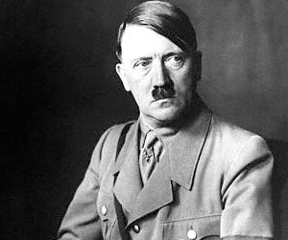
Adolf Hitler
Nickname:________________
Years of Rule:
_______to ________

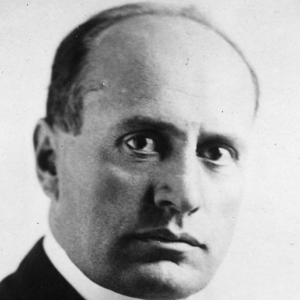
Country:_____________________________________
Political Party:________________________________
Government:_________________________________
Major Characteristics/ideologies, etc.:
*____________________________________________
*____________________________________________
*____________________________________________
*____________________________________________
*____________________________________________
*____________________________________________
*____________________________________________
Benito Mussolini
Nickname:_______________
Years of Rule:_____to ______

