List the appropriate Renaissance person responsible for each of the following images:



1._________________________________



2. _________________________________



3. _________________________________



7. _________________________________________



8. ________________________________________



9. ________________________________________



4. __________________________________________



5. _________________________________________



10. ______________________________________

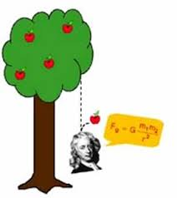

11. ______________________________________

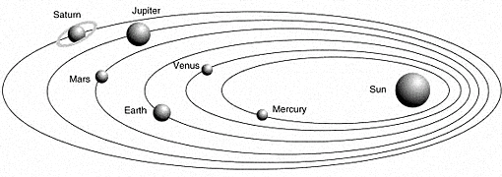

12.________________________________________

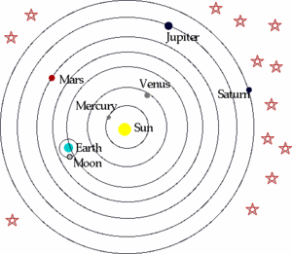

6. ____________________________________