German Totalitarian Leader
__________________________
hated the Treaty of Versailles in which valuable land was taken from Germany. He defied the Treaty of Versailles and began aggressive acts by moving troops into the __________________in 1936, taking over all of ___________________in 1938 , taking the Sudetenland in 1938, and claiming all of ________________________ in 1939. His next aggressive act would be to invade Poland causing WWII
Label -Germany, Rhineland, Austria, Czechoslovakia (Sudetenland is in the northern part of Czechoslovakia)

Japanese Totalitarian Leader
________________________
made the aggressive move of
invading _________________.
After Japan withdrew from the League of Nations they attacked
________________________.

Label Japan, Manchuria, and China.

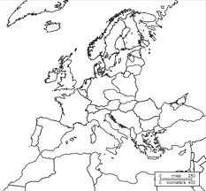
G
E
R
M
A
N
Y
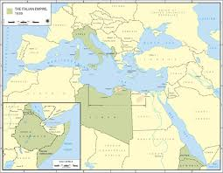
Italian Totalitarian Leader
___________________________ tried to show his new military off by invading
______________________ in 1935 and 1937 because he disliked that Italy did not get much land from the Treaty of Versailles.
This was one place that had remained free/independent of colonial rule during the Age of Imperialism.

Label -Italy, Ethiopia
Italy

Questions to answer.
1. What do all three totalitarian leaders have in common according to this map activity?
___________________________________________________________________________________________________
2. What do you think will happen after all of this aggressive behavior?
____________________________________________________________________________________________________
3. What triggered Germany’s and Italy’s aggressive behavior?__________________________________________________
4. Why did this (answer to number 3) trigger this aggressive behavior?
____________________________________________________________________________________________________
5. According to Germany’s notes, what will trigger or spark World War II?
_____________________________________________________________________________________________________

